**DDL COMMANDS**

**CREATING THE TABLE:**

create table sailors(sailor_ID int,sailor_name varchar(30),sailor_age int,sailor_country varchar(40));

select * from sailors;

insert into sailors values(1,'srihitha',19,'INDIA');

insert into sailors values(2,'Ravina',18,'GERMANY');

insert into sailors values(3,'mohana',20,'AUSTRALIA');

insert into sailors values(4,'meghana',21,'PARIS');

insert into sailors values(5,'supriya',17,'canada');

insert into sailors values(6,'supritha',21,'JAPAN');

insert into sailors values(7,'sangeetha',22,'EUROPE');

select * from sailors;

OUTPUT:

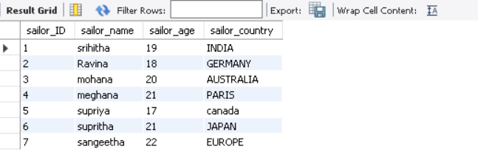

**ALTER THE TABLE:**

**1.ADDING THE COLUMN**

alter table sailors add sailors_email varchar(255);

select * from sailors;

OUTPUT:

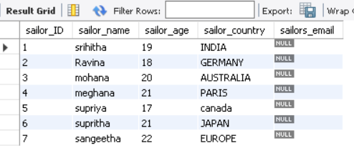

**2.DROPING THE COLUMN**

alter table sailors drop column sailors_email;

select * from sailors;

OUTPUT:

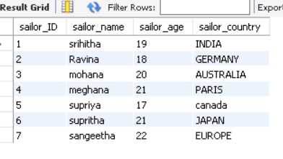

**3.MODIFYING THE COLUMN**

alter table sailors modify column sailor_name char(40);

desc sailors;

OUTPUT:

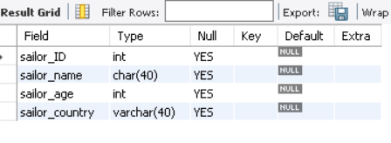

**4.TRUNCATE**

truncate table customers;

select * from customers;

OUTPUT:

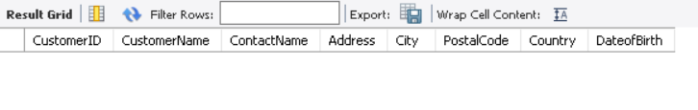

**5.DROP TABLE**

drop table book;

select * from book;

OUTPUT:

